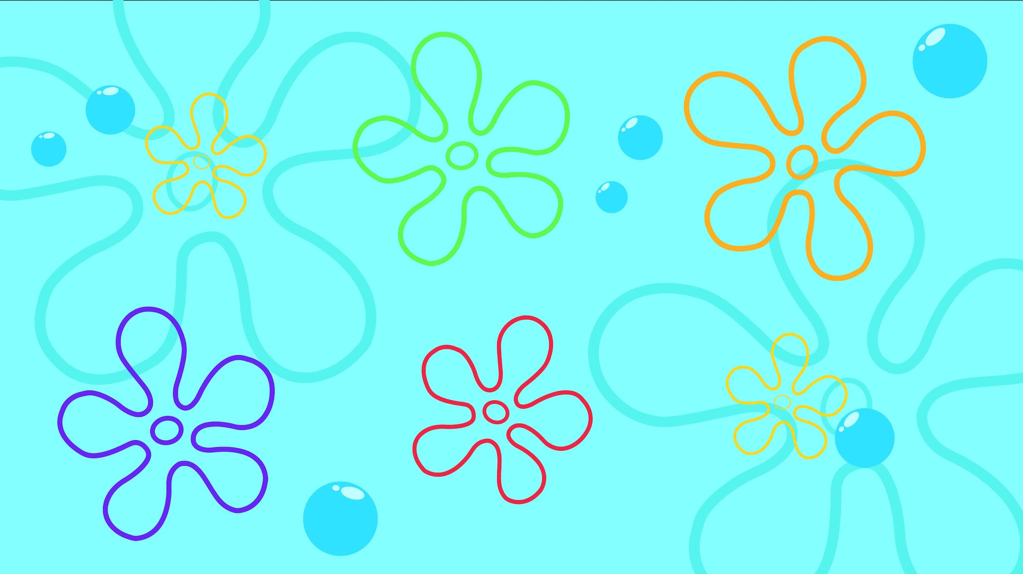

Master Detail App Proposal

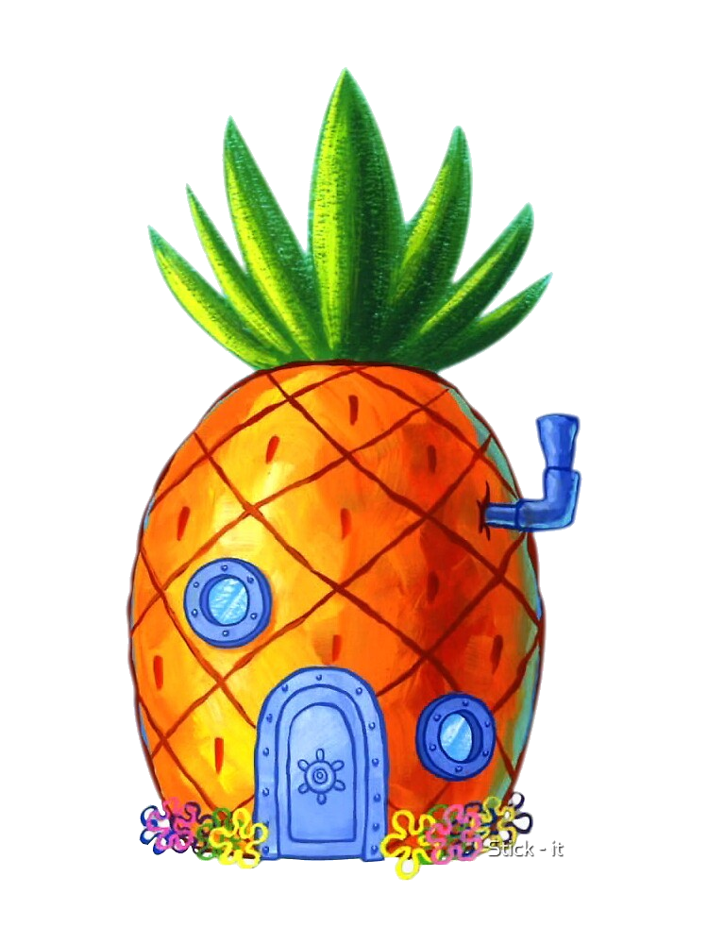

The Doodle Bobs Present:

Mel Eman

Shane Reed

Nicole Corey

Name of app here

8/31/2023

Table of Contents

***Application Description* 3**

***General Purpose:* 3**

***Data Set* 3**

***User Stories* 4**

***Wireframes* 5**

***Class Diagrams* 6**

***Sprint Reflection* 7**

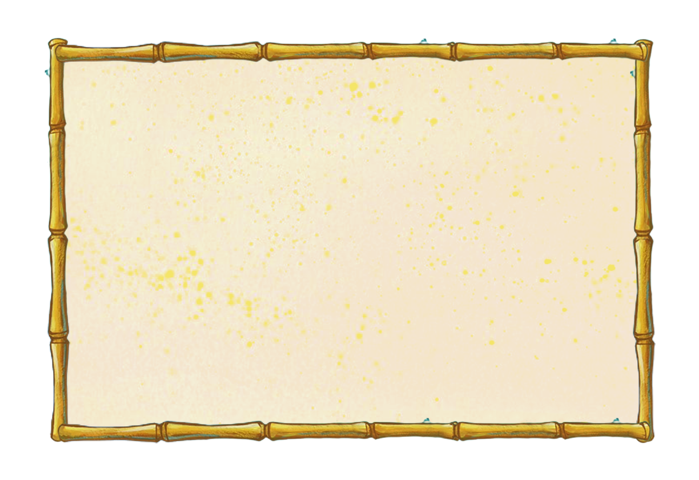

# Application Description

## General Purpose:

*This is where we put the function of the app.*

## Data Set

*List of our data*

# User Stories

|  |  |  |  |
| --- | --- | --- | --- |
| ***As a/an…*** | ***I want to…*** | ***So that…*** | ***Acceptance Criteria*** |
|  |  |  |  |
|  |  |  |  |
|  |  |  |  |
|  |  |  |  |
|  |  |  |  |

# Wireframes



# Class Diagrams

Two Weeks Later…

# Sprint Reflection